Stranger than Fiction

Discuss the following concepts with a partner. How do they relate to each other?

- Read the following newspaper headline. What do you think the piece of news will be about?

- Listen to the recording about what happens in an American home. What is the piece of news about?

- After listening to the recording complete the chart below with the corresponding information

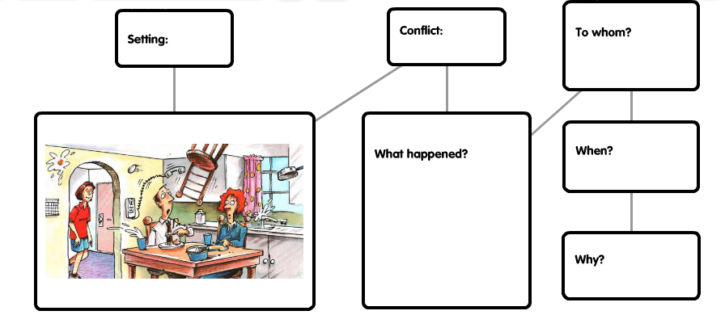

- Complete the following dialogue between the reporter and the 14-year-old girl. What questions do you think the reporter made? What answers did the girl give?

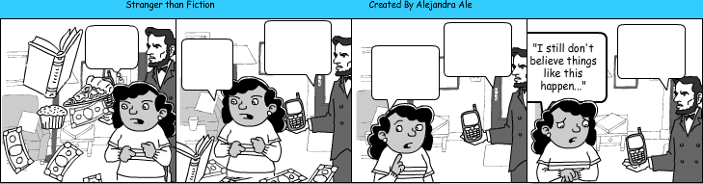

A Framework for Materials Writing:
The T did a brief analysis of the materials at her disposal from the coursebook/teacher‘s book: “Good news, bad news” from the unit “Stranger than Fiction”. The identification of the need came by realizing that there was not a clear link between two parts of the same unit. Furthermore, Ss were plunged directly into a listening activity before setting them into the mood of the unit. Also, instructions were not clear precisely because some steps were missing (Identification stage). Therefore, it was necessary to create materials that would work as a pre-task to the listening activity and that would at the same time activate the other subthemes of the unit (Exploration of need).
The materials provided for the pre-task as well as the while and post-listening activity are relevant and suitable to the context of this story as well as for the other subthemes that the unit deals with (Contextual realization of materials). The main reason why it was necessary to provide extra material was due to a failure in the pedagogical realization of the materials. The coursebook material failed to provide clear exercises and activities that somehow meet the need for the language learning work that has been initially recognized.
As regards Physical production, it can be said that in terms of legibility the typefaces used to present text belong mainly to the category “Sans serif” for headings and captions. For the newspaper headline the typeface used belongs to the “Serif” category. The only decorative (and intricate) typeface is used in the pre-task wordle for students to try to read carefully each one of the words so that they can make connections. In terms of Readability, there is use of contrast to make the title stand out from instructions, alignment to lead the reader through the design, proximity in the case of the graphic organizer for students to follow a certain path, and negative space to give it a clear outlook and style.

